1. commanding leader-Xi Jinping

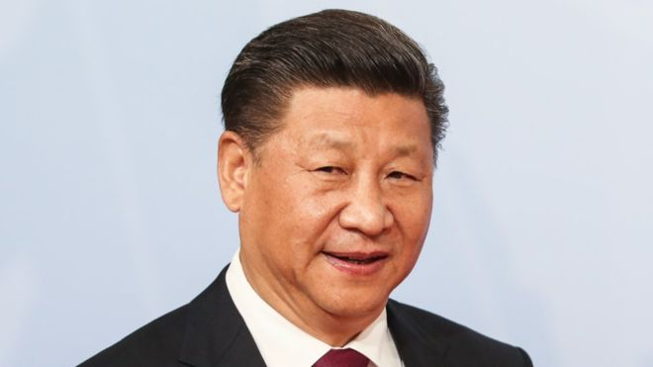

1. visionary- Elon Musk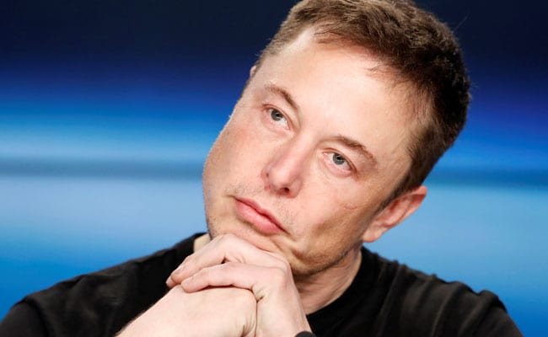
2. affiliative-Nelson Mandela

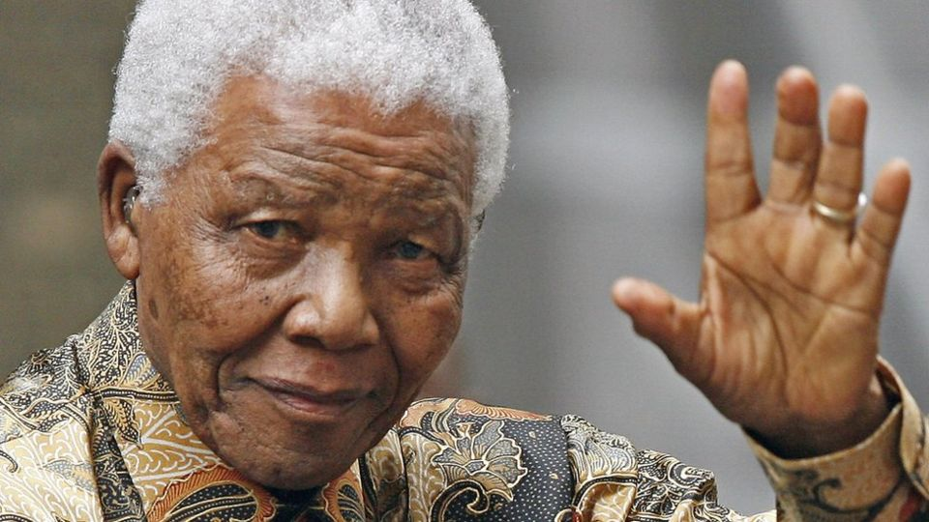

1. democratic-Mark Zuckerberg

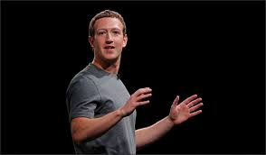

1. pace-setting- Pope Fransis

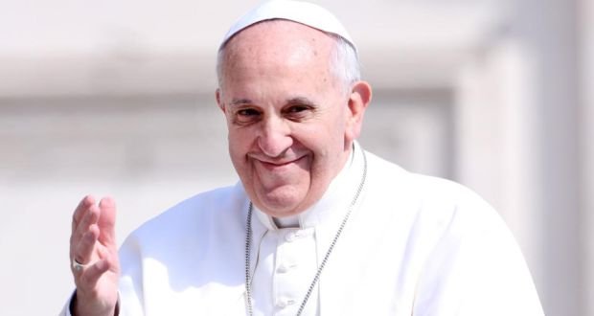

1. coaching leader- Barak Obama

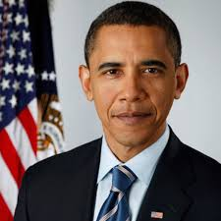

1. autocratic-Bill Gate

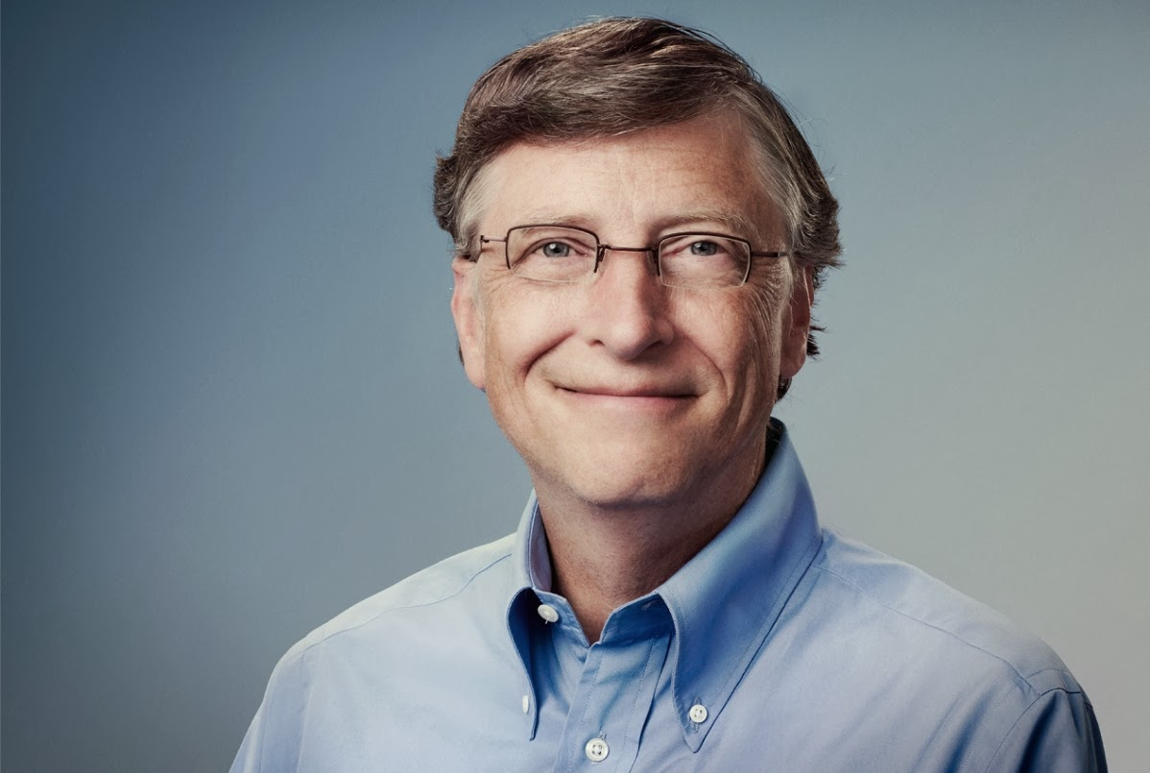

1. transactional leadership-Paul Polman

